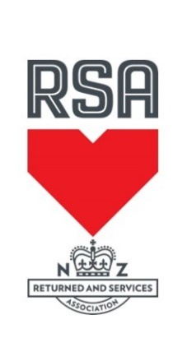

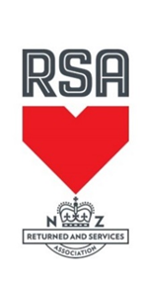


RNZRSA National Snooker Pairs 2026
Venue: Tokoroa Club Inc, 36 Chambers Street, Tokoroa
Date: 30th & 31st May 2026
Start Time: 7.45am for 8am Start
Entry Fee: $160.00 per Pair
Closing date: 22nd May 2026
Limited to: 64 Pairs
Dress Code: One colour long sleeve shirt fastened at the wrists, plain or patterned bow tie, dress trousers & dress shoes.
To enter you must be a financial member of an RSA.

Entries to: Michelle Felton
Email: accounts@tokoroaclub.co.nz
Phone queries: 07 886 5139

Pay your entry fee by direct credit into:
Account name Tokoroa Club Inc
Account number: 02-0464-0026188-03
Particulars Your Name
Code RNZRSA Pairs

Tokoroa Club Inc
P O Box 53
TOKOROA 3444
Phone 07 8865 139
Email: accounts@tokoroaclub.co.nz
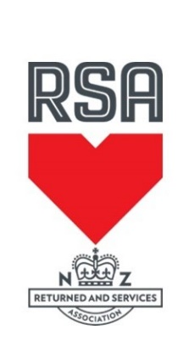

RNZRSA National Snooker Pairs 2026
30th & 31st May 2026
Entry Form
Club Name: __________________________ Contact Phone: _____________
Contact Person: ___________________________________________________
Email Address: ____________________________________________________
ENTRY FEE $160 PER PAIR
Entries must be received by 5pm Friday 17th October 2026
Please indicate whether Returned, Service or Associate.

Players Names RSA Number RET/SER/Ass

- ________________________________________________________________________
________________________________________________________________________
- ________________________________________________________________________
________________________________________________________________________
- ________________________________________________________________________
________________________________________________________________________

Total Entry Fee to be Paid (number of pairs X $160) = ____________________________

I declare that the above-named persons are current financial members of the RSA and that the membership categories as indicated are correct

Signed by Secretary/Manager: _____________________________ Date: ___________

Tokoroa Club Inc
P O Box 53
TOKOROA 3444
Phone 07 8865 139
Email: accounts@tokoroaclub.co.nz
Accommodation in Tokoroa

Clifton Court Motel 111 Main Road, Tokoroa Ph 07 886 4579
Website: www.cliftoncourtmotel.co.nz

Most of the units at Clifton Court Motel have been completely renovated back to new, with new furnishings and large flat screen TV's. Both business and family travellers can expect to find an option to suit, with our spacious, ground floor, smoke free units at affordable prices. Choose from Standard or Family Rooms all with Queen Size beds, tea and coffee facilities & FREE Ultra Fast Wireless Internet (Wi-Fi). The recent addition of our executive units offer the most discerning traveller that extra night of luxury and comfort.
The South Waikato region abounds with wonderful natural attractions, all within easy access from Tokoroa. Clifton Court Motel is conveniently located on State Highway 1, only a short walk from the town centre, restaurants, cinema and sporting facilities.
We strive to make your stay an enjoyable one, and look forward to welcoming you soon...

Redwood Lodge Motel State Highway 1 North, Tokoroa Ph 0800 545 645
Website: www.redwoodlodgemotel.co.nz

11 spacious ground-floor units (all non-smoking). 3 studio, 2 x 1-bedroom, 6 x 2-bedroom units (sleep 1-6). Full cooking facilities in all units. Cooked and continental breakfasts are available. Guest BBQ area. Sky TV. WiFi. 24Hr Satellite security System. Ample off-street parking. Rural setting on northern edge of Tokoroa, 3 minutes from town centre and restaurants. Close vicinity to golf courses, sports and recreational facilities, indoor swimming complex and scenic walking tracks.

Campervan Parking at Tokoroa Club
53 Chambers Street, Tokoroa Ph 07 8865 139

Our club is an official Park over Property for members of NZMCA with Certified Self Containment
We have 6 sites with power and water available for your comfort during your stay. You must have a current Electrical WOF to use these power connections

Charge $10 per vehicle per night

