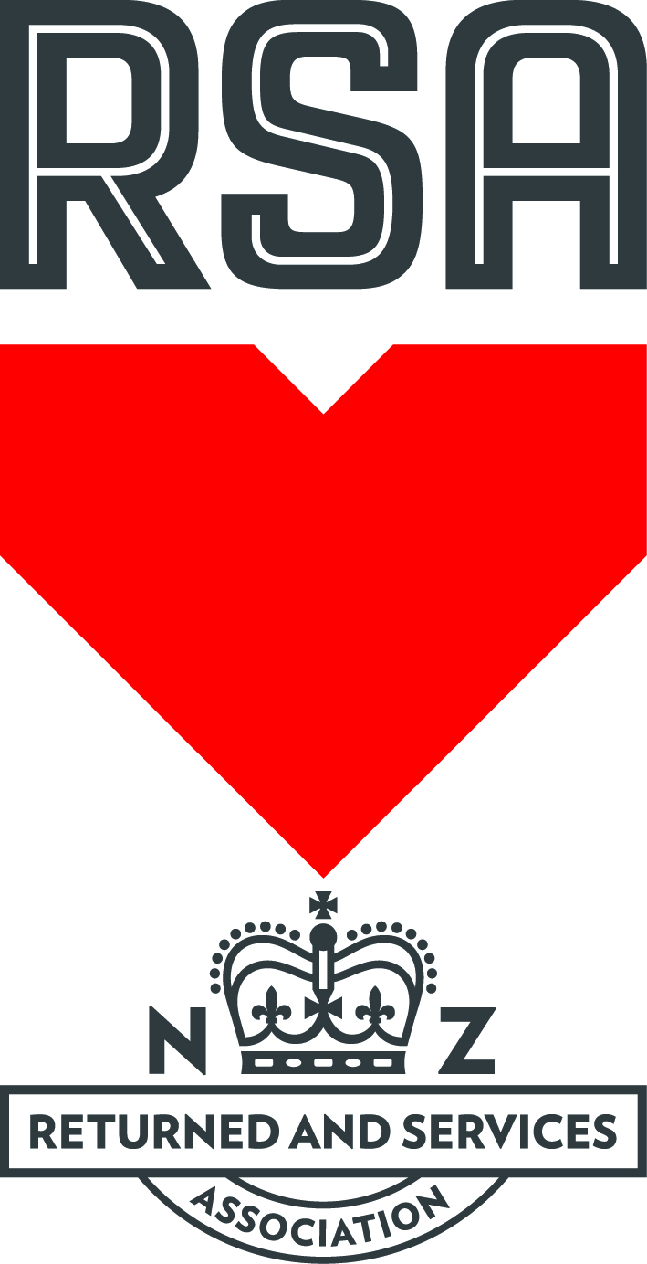

2024 65th NZRSA NATIONAL GOLF TOURNAMENT
Hosted by CLUBS HASTINGS (Inc)
Saturday 2nd November – Wednesday 6th November 2024
Golf Venue - Hawkes Bay Golf Club, 114 Valentine Road Bridge Pa, Hastings 4175

Open to All RSA members who are (18 Hole) NZGA affiliated members
Entry $200.00 (includes Prize Giving Night)
Payable to Clubs Hastings by internet banking 02-0644-0019700-08
with Christian and Surname as reference.

Entries Close Monday 14th October 2024.

PROGRAMME
Saturday 2nd November 2024 – Registrations at Clubs Hastings crn Victoria Street,
Hastings Street & Albert Street, Hastings. Meet & Greet from 4.00 pm.

Sunday 3rd November – Mixed Foursomes alternate shots Men odd number tees
Women even number tees Stableford (played in sixes).
Non mixed players Stableford.
Tee off from multiple tees from 12.30 pm.

Monday 4th November – 1st Round Championship 3 Divisions Men Gross & Nett
1 Ladies Division Stableford.
Tee off multiple tees from 12.30 pm.

Tuesday 5th November – 2nd Round Championship 3 Divisions Men Gross & Nett
1 Ladies Division Stableford.
Tee off multiple tees from 9.30 am.
Melbourne Cup at Clubs Hastings from 3.00 pm.

Wednesday 6th November – Mens 4BBB & Ladies 4BBB.
Tee off multiple tees from 8.00 am.
Official Dinner & Prizegiving 6.30pm sharp at Clubs Hastings

Tournament Chairman
Allen Connor 027 62 47 287

NB: Change of Tournament organisers from original entry form.

PLEASE DISCARD PREVIOUS ENTRY FORM & INFORMATION. THIS IS NEW & UP TO DATE.

2024 65th RNZRSA NATIONAL GOLF TOURNAMENT
Hosted by Clubs Hastings
Saturday 2nd November – Wednesday 6th November 2024
Golf Venue - The Hawkes Bay Golf Club

Open to All Financial RSA members who are (18 Hole) NZGA affiliated members

ENTRY FORM
Entries Limited to 120 Players – Entries Close Monday 14th October 2024

Entries to: Golf Section Fees
Clubs Hastings (inc) All Players $200.00
PO Box 560 Non Players $120.00
HASTINGS 4156
Phone: 06 87 88 808 Full Payment must accompany entry
Email: info@clubshastings.co.nz Website: www.clubshastings.co.nz

Clubs Hastings BNZ Account Number: 02-0644-0019700-08

Name:
Address:
Phone: Mobile:
Email:

Membership Details (confirmation of financial status)
RSA | Membership #
Secretary Name | Secretary Signature

Golf Club
NZGA (ID) (7 Digits) | Handicap Index

Competitions Entered
 | Y | N |  | Y | N
Mens/Ladies Four Ball Best Ball |  |  | Partners Name
Mixed Foursome |  |  | Partners Name
Motorised Cart Required |  |  | Willing to share
The payment for cart hire will be notified at registration and payment required at registration
Own Motorised Cart |  |  | Willing to share
Pull Trundler Required
Age Over 70 years |  |  | Age over 80 years

General Information
Accompanied by Partner | Name
Number attending prizegiving dinner | Number Attending
Participating in the Non Golf Partners Programme |  | Y | N

Signed Date
Practice rounds prior to Tournament can be booked. Contact: HB Golf Club: 06 87 98 890.
Tournament Chairman: Allen Connor 027 64 47 287

2020 NZRSA NATIONAL GOLF TOURNAMENT

TRANSPORT REQUEST FORM

Saturday 2nd November – Thursday 7th November 2024

Please return with entry form: Transport will be available to and from Hawkes Bay Airport to listed accommodation with this entry form.

Secretary
Clubs Hastings
308 Victoria Street, Hastings. PO Box 560, Hastings
P: 06 87 88 808 E: info@clubshastings.co.nz

ARRIVAL DETAILS

CLUB: _____________________________________________________________

TEAM CONTACT: ______________________ CELL: __________________________

ACCOMODATION: ____________________________________________________

DATE: ________________ FLIGHT: ________________ TIME: ________________

NUMBER OF PERSON: ___________

DEPARTURE DETAILS:

CLUB: _____________________________________________________________

TEAM CONTACT: ______________________ CELL: __________________________

ACCOMODATION: ____________________________________________________

DATE: ________________ FLIGHT: ________________ TIME: ________________

NUMBER OF PERSON: ___________

If travel arrangements are not provided in advance we may not be able to provide transport. Please only for those without private transport.

ACCOMMODATION HASTINGS / HAVELOCK NORTH

Fairmont Motor Lodge 06 8783850
Karamu Road North – 1.2km from Clubs Hastings, 3 min drive.

Valdez Motel 06 8765453 0800 825339
Karamu Road North – 1.1km from Clubs Hastings, 2 min drive.

Magpies Motel 64 6 876 8062 0800 876 878
Karamu Road North – 1.2km from Clubs Hastings, 2 min drive.

Gloucester House 06 8763741 0800 886465
Avenue Road West- 1.5km from Clubs Hastings, 5 min drive.

Claremonte Motor Lodge 06 87 82755 0800 500117
Heretaunga Street West – 2.2km from Clubs Hastings, 5 min drive.

Cumberland Court 06 87 86190 0508 708090
Cnr Mareakakaho Road & Omahu – 2.7km from Clubs Hastings, 6 min drive.

Frimley Lodge Motel 06 87 60519 0800 800 936
Pakowhai Road – 2.4km from Clubs Hastings, 5 min drive.

Omahu Motor Lodge 06 87 07061
Omahu Road – 3.3km from Clubs Hastings, 6 min drive.

The Village Motel 06 87 75401 0508125225
Havelock North – 4.6km from Clubs Hastings, 7 min drive.

Havelock North Motor Lodge 06 87 78627 0508 405405
Havelock North – 4.5km from Clubs Hastings, 7 min drive.

Porters Boutique Hotel 06 87 71234
Porter Drive Havelock North – 4.5km from Clubs Hastings, 7 min drive.

