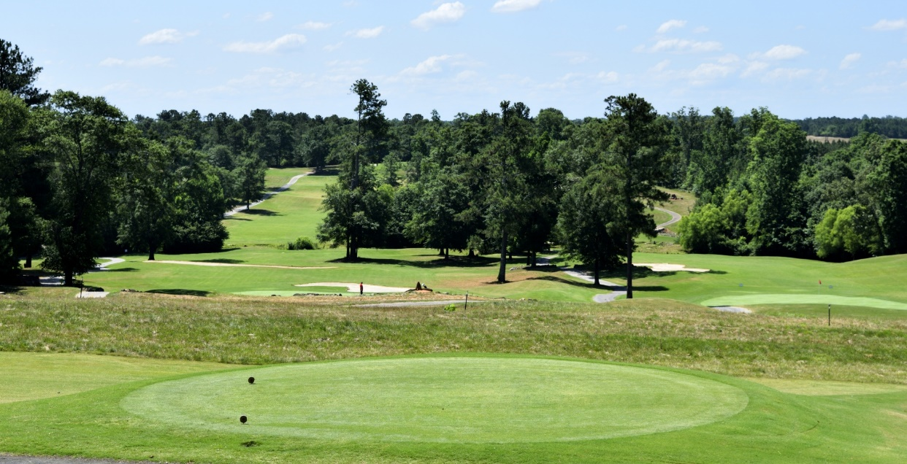

2024 RNZRSA NATIONAL GOLF TOURNAMENT
Hosted by CLUBS HASTINGS
Registration – Saturday 2nd November 2024
Tournament – Sunday 3rd - Wednesday 6th November 2024 at HB Golf Club
Open to ALL RSA members who are (18 Hole) affiliated members
Entry $200.00
(Includes Official Dinner & Prize Giving Night)
Entries Close Monday 14th October 2024

